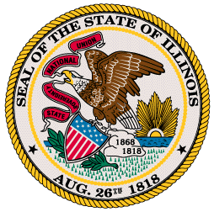
Office of the Governor

Budgeting for Results Commission Meeting
Public Agenda
March 16, 2012
1:00-3:00pm

- Approval of Minutes

- Governor’s Introduced Budget

- Budget Negotiation Update

- BFR Implementation

- Stakeholder Engagement

