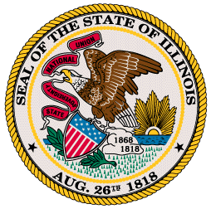
Office of the Governor

Budgeting for Results Commission Meeting
Public Agenda
June 22, 2012
1:00-3:00pm

- Minutes

- Ethics Forms and Review

- Session/ Budget Update

- BFR Implementation Update

- Intro of BFR Fellows

- Review of 2011 Commission recommendations and action plans

